**Business Requirements Document(BRD)**

**Project Title**: Empowering Digital Learning with a Study Organizer.

**Date**: November 19,2024

**1. Project Overview**

The project is aimed at creating a comprehensive digital learning platform designed to help students overcome the challenges posed by online education. With the transition to online learning, students face various difficulties such as staying organized, managing assignments and deadlines, and staying motivated and engaged without the structure of a traditional classroom environment. This platform will address these issues by providing a robust set of features designed to enhance organization, motivation, and engagement.

The application will leverage modern technologies including ASP.NET Core Web API for the backend, Angular for the frontend, SQL Server for data management, and Azure for cloud deployment. By using these technologies, we aim to deliver a scalable and responsive web application that helps students manage their learning experience effectively.

**2. Business Notes**

* **Key Pain Points Addressed**

**Lack of Organization**: Online learners often struggle with managing assignments, deadlines, and lecture materials, leading to disorganization and stress. Our platform’s assignment management and note-taking systems will help students stay on top of their tasks.

**Motivation and Engagement**: Without the physical presence of instructors and peers, students can feel isolated and disengaged. The streaks feature and leaderboard system will motivate students to stay consistent and perform well by tracking their progress and encouraging competition.

**Feelings of Isolation:** The lack of peer interaction in online education can lead to loneliness and a sense of disconnection. By centralizing important resources and creating an environment for tracking progress together, we aim to create a sense of community and engagement among students.

**Difficulty in Finding Reliable Study Resources:** Students may struggle to access the right study materials. The integration of free APIs for educational resources will offer easy access to supplementary materials, enhancing the learning experience.

* **Business Benefits**

Enhanced Student Organization: With features like assignment management and note-taking, students will be able to manage their time and tasks more effectively, leading to improved academic performance.

Increased Motivation: The streaks and leaderboard systems will provide students with the motivation to consistently meet deadlines and engage in their coursework, leading to better retention and success.

Improved User Engagement: Centralized access to important features such as assignments, notes, and study resources will reduce confusion and encourage consistent interaction with the platform.

Support for Self-Directed Learning: By offering a structured, personalized digital learning environment, the platform will help students take control of their learning journey and reduce the sense of being overwhelmed by unorganized content.

Scalability and Reliability: The cloud-based Azure deployment ensures that the platform can scale as the user base grows and can be trusted to provide reliable service without downtime.

**3.Stakeholders**

* **Primary Stakeholders**:
  + **Students**: The end-users who will benefit directly from the platform's features aimed at improving organization, motivation, and engagement.
  + **Educators**: Teachers or instructors who will utilize the platform to assign tasks, provide resources, and track student progress.
* **Secondary Stakeholders**:

* + - * + **Administrators**: Users who will manage platform settings, monitor usage, and ensure smooth operation of the platform.
        + **Development Team**: The technical team responsible for the design, development, and maintenance of the platform.
        + **Cloud Providers (Azure)**: The service provider hosting the platform’s infrastructure and providing support for scalability and cloud integration.
* **Tertiary Stakeholders**:
* **API Providers (Educational Resources)**: Organizations providing free educational tools and resources that will be integrated into the platform.
* **Investors/Funders**: Individuals or institutions providing financial backing for the project.

## **4.Functional Requirements**

### ****Assignment Management****

* **Create, Read, Update, Delete (CRUD)**: The system should allow users (students and educators) to create, view, update, and delete assignments.
* **Due Date Tracking**: Each assignment should have a due date, and the system should send reminders as the deadline approaches.
* **Progress Tracking**: Users should be able to mark assignments as in-progress, completed, or pending, and track their overall completion percentage.

### ****Note-Taking System****

* **Create, Edit, Delete Notes**: The application should support text-based note creation with the ability to edit and delete notes.
* **Tagging**: Notes should be categorized by tags to enable easy search and organization.
* **Attach Resources**: Notes should support the attachment of files and links for additional resources.

### ****Session Tracking****

* **Session Log**: Students should be able to log lecture sessions, discussions, and related resources.
* **Search Functionality**: Users should be able to search for session topics, resources, and associated notes.

### ****Streaks and Leaderboard****

* **Streak Tracking**: The system will track streaks for assignment submission, rewarding students who consistently submit their work on time.
* **Leaderboard**: Display a leaderboard ranking students based on their streaks to encourage friendly competition and motivation.

### ****User Authentication****

* **Secure Login**: The system should allow users to register, log in, and log out securely.
* **Role-Based Access**: Different roles (student, educator, administrator) should have different levels of access to the platform's features.

## **5. Non-Functional Requirements**

* **Performance**: The platform should be able to handle high user traffic without significant slowdowns, with an expected response time for actions under 3 seconds.
* **Availability**: The system should be available 99.9% of the time, with downtime occurring only during scheduled maintenance.
* **Security**: Sensitive data such as user information, assignments, and notes should be encrypted both in transit and at rest.
* **Scalability**: The platform should be able to scale horizontally to support an increasing number of users and data load as the system grows.
* **Accessibility**: The application should be designed to be accessible to users with disabilities, following WCAG guidelines for accessibility.
* **Usability**: The system should have an intuitive, user-friendly interface with minimal learning curve.

## **6. Technical Requirements**

* **Frontend**: The user interface will be developed using Angular, which will provide a dynamic and responsive user experience.
* **Backend**: ASP.NET Core Web API will be used to handle business logic and data processing.
* **Database**: SQL Server will store user data, assignments, notes, session logs, and progress data.
* **Cloud Deployment**: The application will be deployed on Azure, utilizing its cloud services for scalability, data storage, and security.
* **APIs**: The system will integrate with free educational resources APIs to enhance the platform with additional learning materials.

## **7. Database Design**

The database will consist of several key entities:

* **User**: Stores user data including name, role (student/educator/administrator), and login credentials.
* **Assignment**: Stores assignment details including title, due date, tags, and progress.
* **Note**: Stores user-generated notes, including title, content, associated resources, and tags.
* **Session**: Stores session logs including session ID, title, description, and associated materials.
* **Streak**: Tracks user activity and streaks related to timely assignment submission.

The relationships between the tables will be defined with appropriate foreign keys (e.g., a note will be related to a specific user, and assignments will be related to both students and educators).

**8.Block Diagram:**

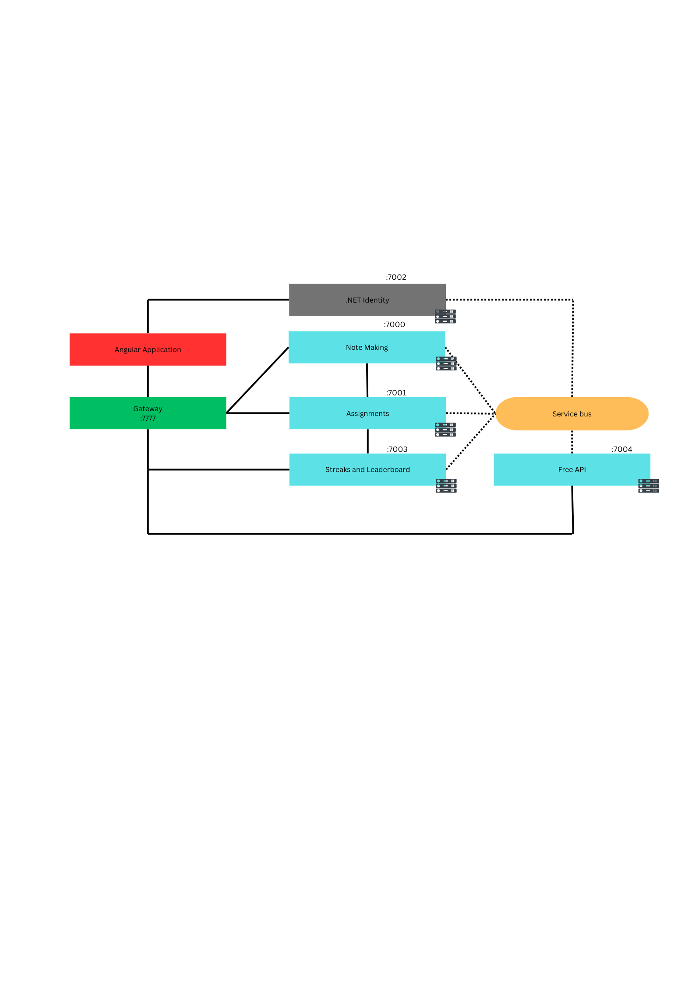

**9.Class Diagram:**

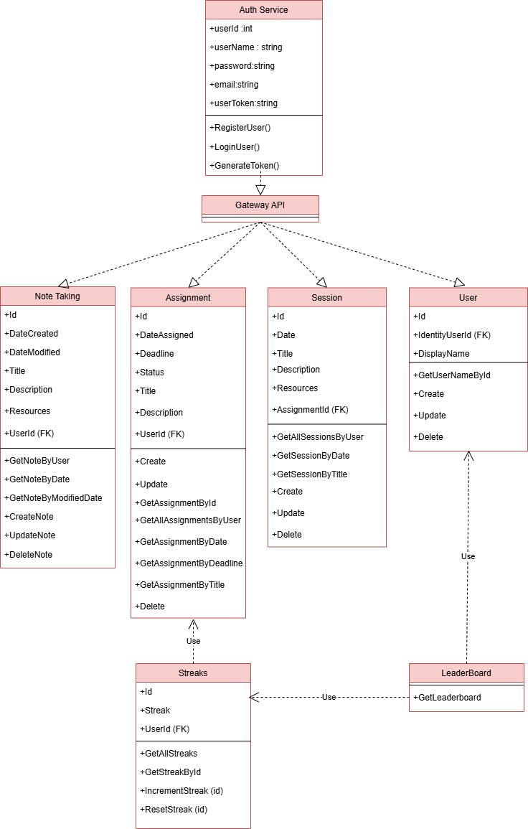

10.UI Diagram

